Eighth International Symposium on Marine Propulsors
smp’24, Berlin, Germany, March 2024

smp’24 Conference Publications Format*

Kourosh Koushan¹, Sverre Steen²

¹Norwegian Marine Technology Research Institute (SINTEF Ocean), Trondheim, Norway
²Department of Marine Technology, Norwegian University of Science and Technology (NTNU), Trondheim, Norway

ABSTRACT
Preparing a manuscript in Acrobat pdf format or with MS-Word for Windows. Manuscripts must be prepared in English and must consist of: title, full names of all authors, affiliation(s), abstract, keywords, text, reference, tables and figures. The manuscript generally should not exceed eight pages (recommended length). The complete manuscript including figures and tables should be submitted online using the SMP’24 conference tool athttps://www.conftool.org/smp24/. A name of an author to which all correspondence or proofs are to be forwarded must be shown clearly therein along with complete address, and e-mail address.
The abstract should not exceed 200 words and be informative of the purpose, methods, results, and conclusions.

Keywords
Up to five keywords should follow the abstract.

1 INTRODUCTION
The smp’24 Proceedings and conference Summary are the records of the conference，we hope to give the books a single, high-quality appearance. To do this, we ask that authors follow some simple guidelines. In essence, we ask you to make your manuscript look exactly like this document. The easiest way to do this is simply to use this template file and replace the content with your own material.

2 PAGE SIZE AND COLUMNS
Manuscript should be prepared on one side of A4 paper with two columns. All material on each page should fit within a rectangle of 17.0 cm x 25.0 cm, centered on A4 page, with a 0.5 cm space between two 8.25 cm columns. The margin settings are: Top: 2.0 cm; Bottom: 2.7 cm; Left: 2.0 cm; Right: 2.0 cm.

3 TYPESET TEXT

* Leave blank the last 2.0 cm on the first page for the editors to place some additional information about this paper in a footnote on the first page if necessary.
Prepare your submissions on a word processor or pdf format. The Conference Proceedings will be prepared from camera ready manuscript. There will be no opportunity for corrections after submission. The responsibility for the appearance of his/her paper remains to the Authors. The Authors are responsible for obtaining security approval for publication from employers or authorities where necessary.

3.1 Normal or Body Text
Please use a 10-point Times Roman font and 12-point line spacing. The line spacing uses “exactly”. Please use 4-point paragraph spacing after each paragraph, i.e. select Paragraph in the Format menu, and change the setting for Spacing After to 4 pt.

3.2 Title and Authors
The title (Arial 14-point bold), authors' names (Times Roman 11-point bold) and affiliations (Times Roman 9-point, 9-point line space) run across the full width of the page – one column 17.0 cm wide. See the example at the top of this page for two names with different addresses. We recommend the following affiliations, Name of the institute, City, State/Province, Country, do not add street names, P.O. Box numbers or zip codes to the affiliations.

3.3 Abstract and Keywords
Every submission should begin with an abstract of about 200 words, followed by a set of keywords. The abstract and keywords should be placed in the left column of the first page. The abstract should be a concise statement of the problem, approach, findings, and conclusions of the work described.

3.4 First Page Notice
Leave 2.0 cm of blank space at the bottom of the first page for the additional information notice. Use 9-point Times Roman font and 12-point line spacing here.

3.5 Subsequent Pages
For pages other than the first page, start at the top of the page, and continue in double-column format. The two columns on the last page should be of equal length.

3.6 Notes
These should be avoided. Insert the information in the text. In tables the following reference marks should be used: *, **, etc. and the actual footnotes are set directly underneath the table.

3.7 References and Citations
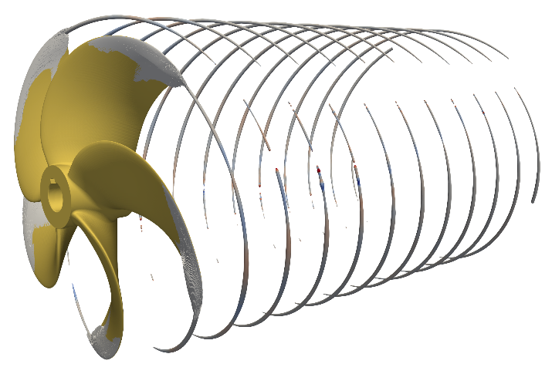
References should be cited in the text with names (without initials) and year written inside parentheses, e.g., "(Atlar 2004) ", "(Brewer et al 2004) " and "(Choi & Kinnas 2001) " , or with the year inside parentheses when names appear explicitly in the text, e.g. "by Brewer et al(2004)." At the end of the manuscript, list all references in alphabetical order underneath the heading REFERENCES (Heading without number tag). The references should be typed in the same style of the body text (Times Roman 10-point and 12-point line spacing) and second and further lines should be indented 4.0 mm. If several works by the same author are cited, entries should be chronological:
Figure 1: Example figure.
Larch, A.A. (1996a). Development ...
Larch, A.A. (1996b). Facilities ...
Larch, A.A. (1997). Computer ...
Larch, A.A. & Jensen, M.C. (1996). Effects of ...
Larch, A.A. & Smith, B.P. (1993). Alpine ...
In bibliographies the order for books and journals are respectively:
Last name, First name or Initials (ed.) (year). Book title. City: Publisher.
Last name, First name or Initials (year). ‘Title of article’. Title of Journal (series number if necessary) volume number (issue number if necessary): page numbers.
The book title and Journal (Proceedings) title are underlined. See the examples of references at the end of this article. References should be published materials accessible to the public. Internal technical reports, proprietary information may not be cited. Private communications should be acknowledged, not referenced (e.g., “[Robertson, personal communication]”).

3.8 Page Numbering
Do not include page numbers in your submission. It will be added when the publications are assembled.

4 SECTIONS
The heading of a section should be in Arial 9-point bold in all-capitals. Sections should be numbered.

4.1 Subsections
The heading of subsections should be in Arial 9-point bold with only the initial letters capitalized. (Note: For sub-sections and subsubsections, a word like the or a is not capitalized unless it is the first word of the header)

4.1.1 Subsubsections
The heading for subsubsections should be in Arial 9-point italic with initial letters capitalized.

5 FIGURES/TABLES AND CAPTIONS
Figures and tables should be numbered sequentially in the order cited in the text and legends of the figures must be placed at proper locations in the text. Figures and tables should appear on appropriate pages and legends should appear at the bottom of the sheet. Colorful figures are permitted in proceedings CD but only black and white figures are available in printed proceedings. Offering original of photos is suggested for ensuring the quality of the photos in proceedings. Captions should be Times New Roman 9-point bold. They should be numbered (e.g., “Table 1” or “Figure 2”). Captions of the figures should be placed below the appropriate figure, and captions of the table should be placed at the top of the table. Footnotes may follow tables for further information.
Examples are shown in Figure 1 and Table 1.
Table 1: This is a table.
A | B | C
1 | 2 | 3
2 | 2 | 3

6 EQUATIONS
Use the equation editor of the selected word processing program. Equations are centered at each column. Number equations consecutively and place the number at the end of the line, between parentheses. Refer to equations by these numbers. See for example Equation (1) below:
$$K_{t}={\left(1-\frac{R^{2}τ}{c_{a}+ν \tan{δ}}\right)}^{4}k_{1}$$ | (1)
Where $c_{a}$ = interface adhesion; $δ$ = friction angle at interface; and $k_{1}$ = shear stiffness number.

ACKNOWLEDGEMENTS
This work has been funded by Research Agency AB. Furthermore, the authors would like to express their gratitude to Professor XY for the fruitful discussions which have been of high value for the presented paper.

REFERENCES
Atlar, M. (ed.) (2004). First International Conference on Technological Advances in Podded Propulsion. School of Marine Science and Technology, University of Newcastle, UK.
Gibson, I. & Lewis, R. I. (1973). ‘Ducted propeller analysis by surface vorticity and actuator disk theory'. Proceedings of the Symposium on Ducted Propeller, RINA, Teddington, England.
Kerwin, J. E., Kinnas, S. A., Lee, J.-T. & Shih, W.-Z. (1987). ‘A surface panel method for the hydrodynamic analysis of ducted propellers’, Transactions of Society of Naval Architects & Marine Engineers 95.
White, F. (1986). Fluid Mechanics. 2nd ed. Mcgraw- Hill Book Company.

